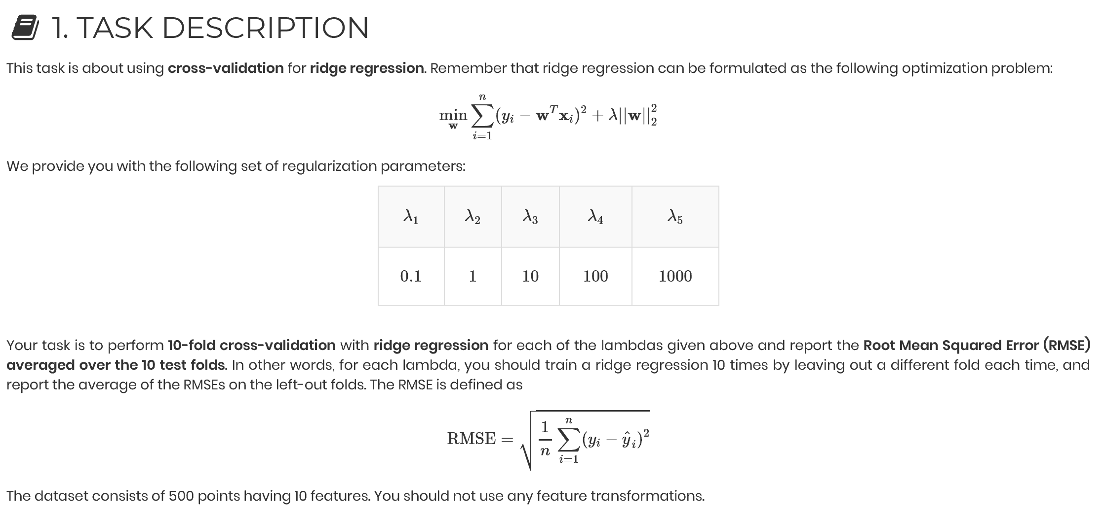

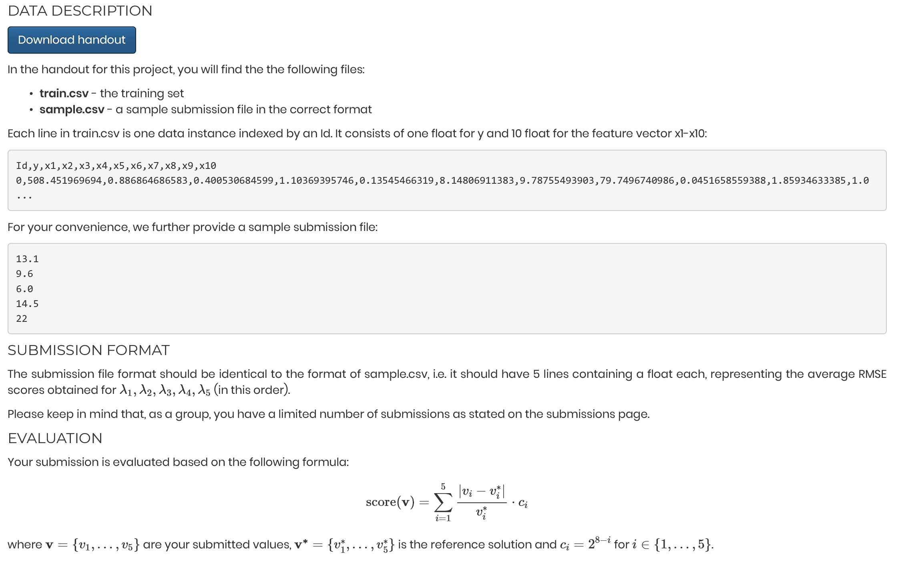

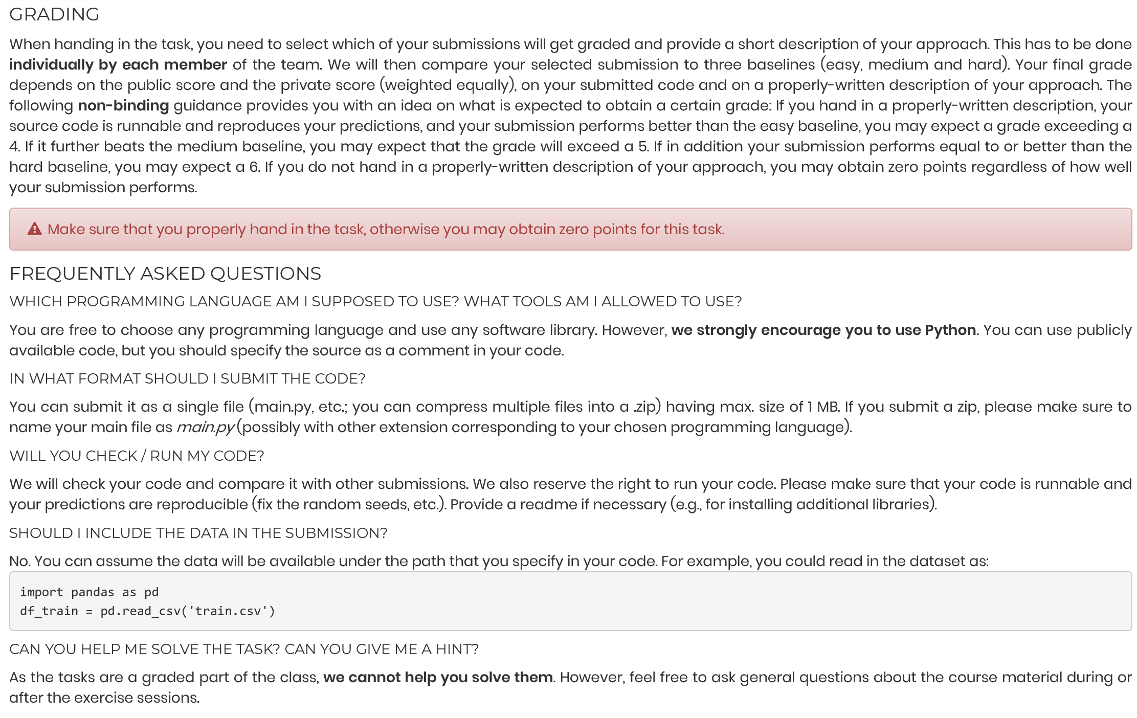

After reading and dividing the training set into a y and an X part, we defined the negative root mean squared error (NRMSE) as a scoring function. Then, we defined a ridge object and set the regularization parameter to the first value (alpha/lambda = 0.1). A ridge regression of y on X was conducted with 10-fold cross-validation, using the previously defined NRMSE as scoring parameter (want the RMSE to be as small as possible 🡪 maximize negative value of it). We stored the RMSE score from the output and repeated the steps for the remaining values of alpha/lambda. Eventually, we created a vector with all resulting RMSE scores for the ridge regressions with different regularization parameters.